Integration project

Presentation

**(ZARA)**

ZARA is worldwide famous cloth –designing brand which usually made clothes for both men and women and for kids also. Our client ,manager of Zara –official manger wants a online marketing so our employees Gurtek singh and Manmeet thind working on zara website.

**About Zara**

**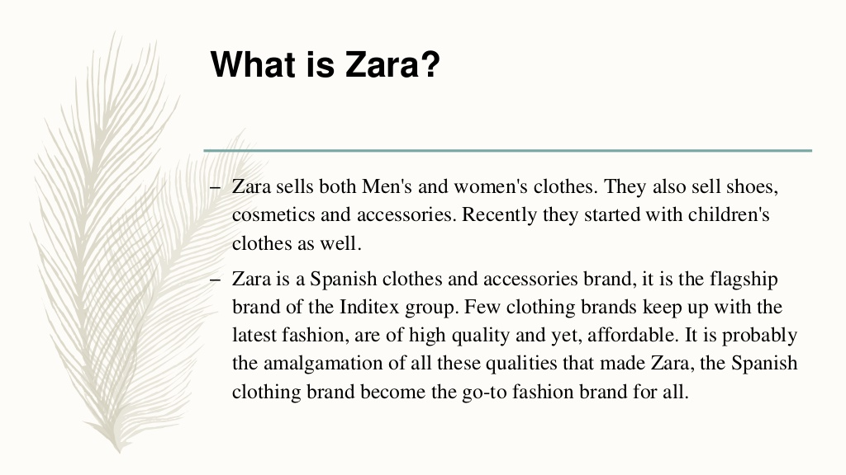**

Zara is worldwide famous Spanish brand .mostly known for their cloth designing and for their other accessories such as colognes and wallets for men and women.

**HISTORY AND FOUNDERS OF ZARA**

**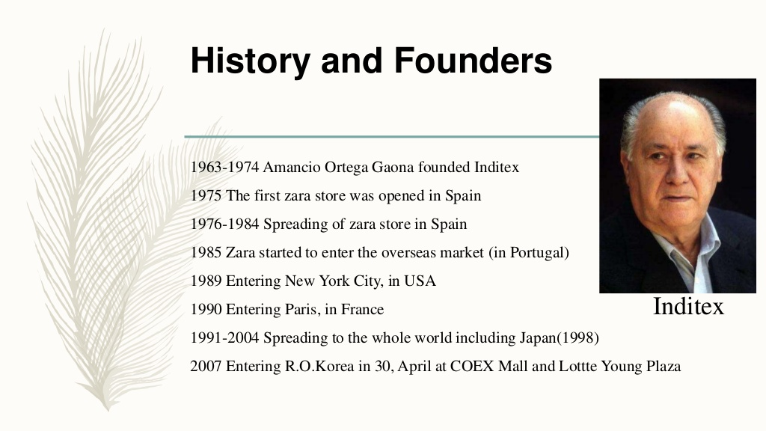**

[Amancio Ortega](https://en.wikipedia.org/wiki/Amancio_Ortega) opened the first Zara store in 1975 in central [A Coruña](https://en.wikipedia.org/wiki/A_Coru%C3%B1a), Galicia, Spain. Ortega initially named the store *Zorba* after the classic film *[Zorba the Greek](https://en.wikipedia.org/wiki/Zorba_the_Greek_(film)" \o "Zorba the Greek (film))*, but after learning there was a bar with the same name two blocks away, they rearranged the letters molded for the sign to "Zara". It is believed extra "a" came from an additional set of letters that had been made for the company.

**EXPANDATION OF ZARA**

In 1985, Amancio Ortega set up a parent company for Zara before going for the global expansion, and in 1988, the company started its international expansion through [Porto](https://en.wikipedia.org/wiki/Porto), Portugal.[[10]](https://en.wikipedia.org/wiki/Zara_(retailer)#cite_note-10) In 1989, it entered the [United States](https://en.wikipedia.org/wiki/United_States), and then [France](https://en.wikipedia.org/wiki/France) in 1990.[[11]](https://en.wikipedia.org/wiki/Zara_(retailer)#cite_note-11) During the 1990s, Zara expanded to [Mexico](https://en.wikipedia.org/wiki/Mexico) (1992),[[12]](https://en.wikipedia.org/wiki/Zara_(retailer)" \l "cite_note-12) [Greece](https://en.wikipedia.org/wiki/Greece), [Belgium](https://en.wikipedia.org/wiki/Belgium) and [Sweden](https://en.wikipedia.org/wiki/Sweden) (1993). In the early 2000s.

**MANUFACTURING AND DISTRIBUTION**

**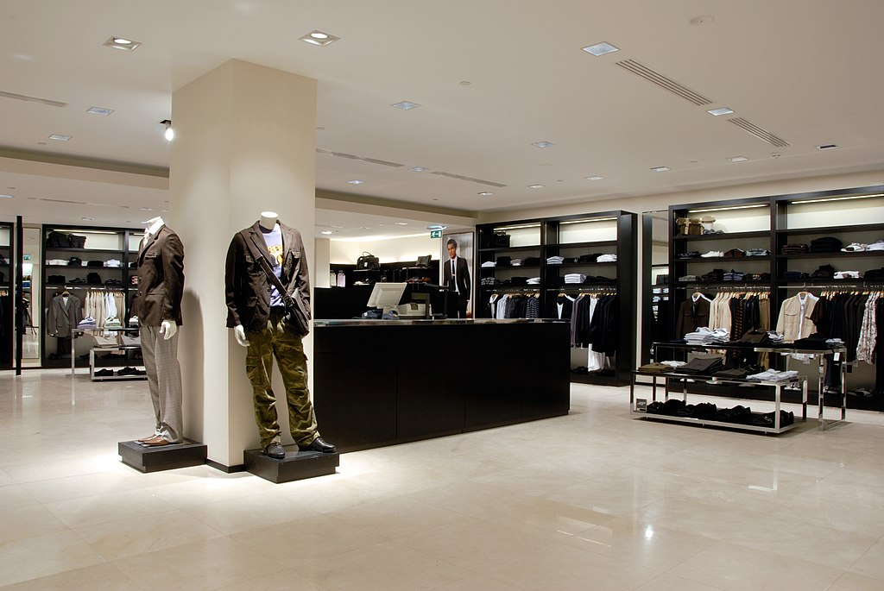**

Zara needs just one week to develop a new product and get it to stores, compared to the six-month industry average, and makes roughly 40,000 designs of which around 12,000 new designs are carefully selected and produced each year.[[46]](https://en.wikipedia.org/wiki/Zara_(retailer)#cite_note-46) Zara has a policy of zero advertising;[[8]](https://en.wikipedia.org/wiki/Zara_(retailer)" \l "cite_note-ny-8) the company preferred to invest a percentage of revenues in opening new stores instead.

**SUCCESS FACTORS OF ZARA**

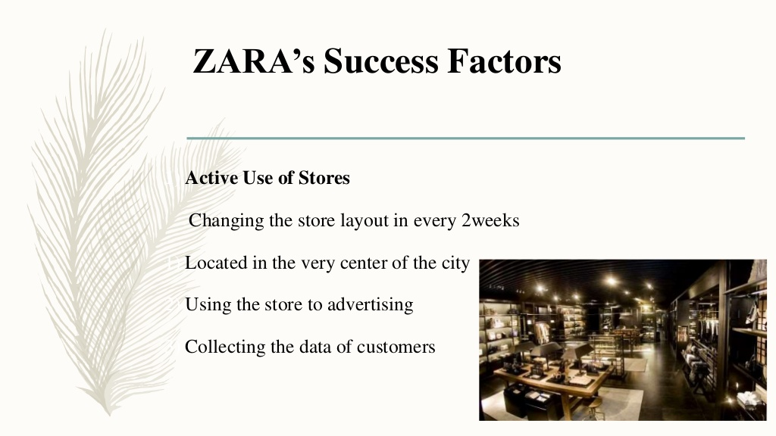

Zara success factor is changing the store layout in every 2 weeks .located in the very center of the city and using the store to advertising .The main factor of zara is collecting the data of customers by taking their feedbacks.

IN THIS PRESENTATION CLIENT ALSO TO WANT US TO EXPLAIN STRENGTH AND WEAKNESS .

**STRENGTH**

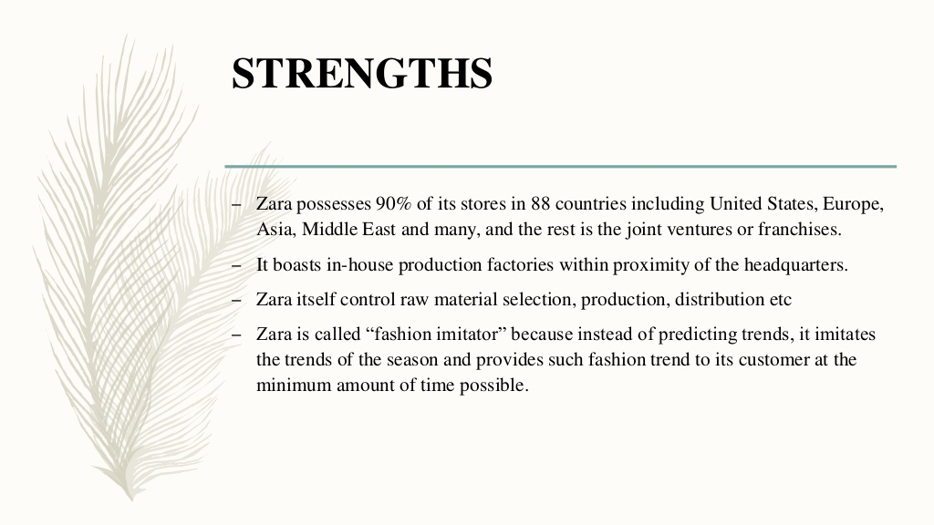

ZARA has main strength that is they control their own raw material selection ,production and distribution.

**Weakness of Zara**

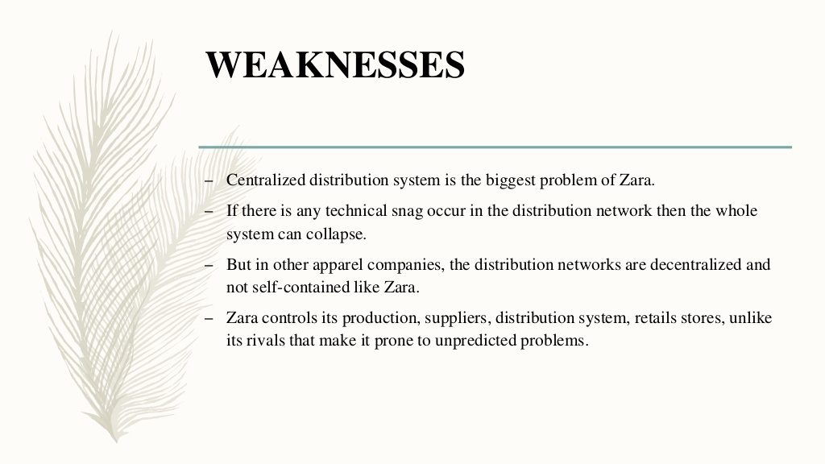

Zara main is strength factor is zara main weakness because if any error occur in distribution network then the whole system can collapse.

**IMPORT POLICY OF ZARA**

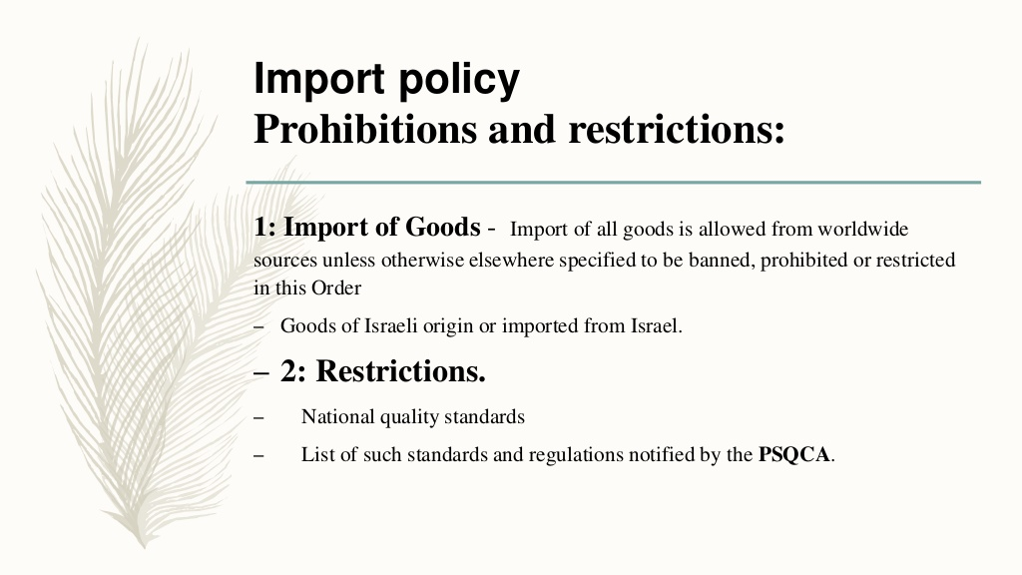

**COMPETITORS OF ZARA**

**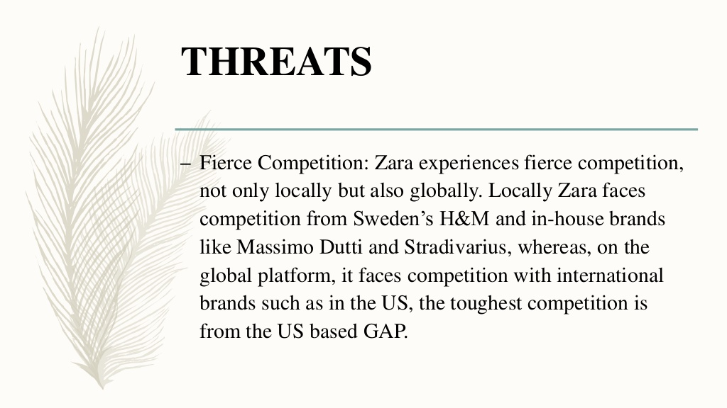**

ZARA is one of the well known and fast growing company in worldwide market because its grows up its market very fast among the locality and being an Spanish brand they gets most popularity in all over the world .ZARA itself is succeedes most top notch companies such as holister ,gap ,h&m they all are most popular American brands and well known competitors of zara.